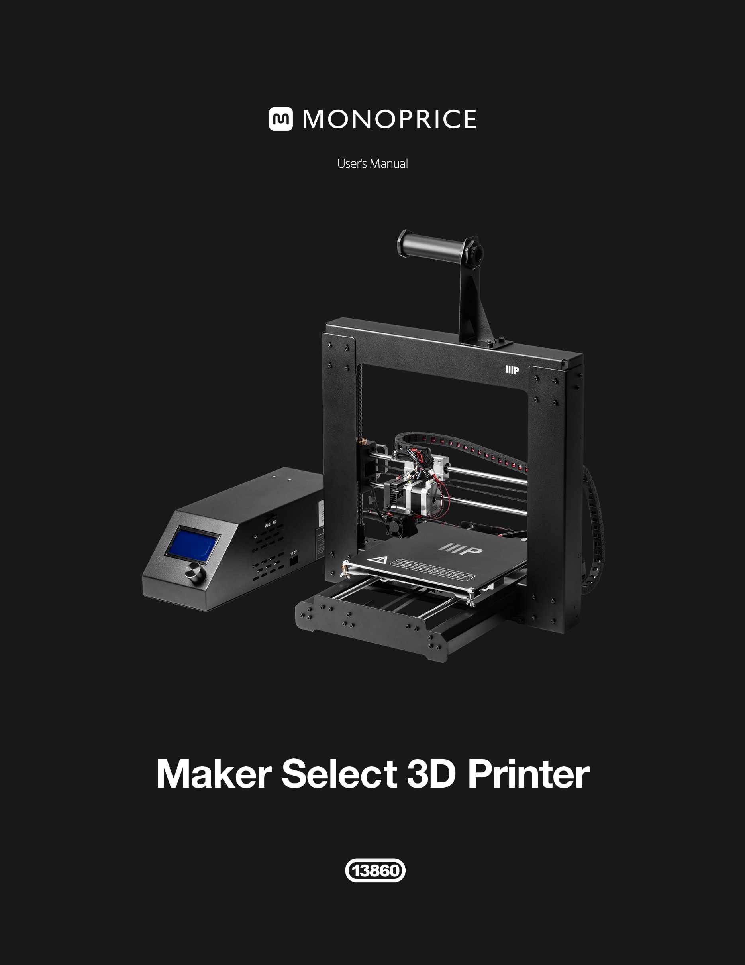

**CONTENTS**

SAFETY WARNINGS AND GUIDELINES 4

INTRODUCTION 5

FEATURES 5

CUSTOMER SERVICE 5

PACKAGE CONTENTS 6

USING THE MENU SYSTEM 7

UNPACKING, ASSEMBLY, AND SETUP 8

FINE TUNING PLATFORM HEIGHT 18

SOFTWARE 20

Installation 20

Quickprint View 27

Full Settings View 30

Basic Tab 31

Advanced Tab 34

Plugins Tab 36

Expert Settings 38

TECHNICAL SUPPORT 44

TROUBLESHOOTING 44

SPECIFICATIONS 47

APPENDIX A: CONTROL BOX MENU REFERENCE 48

Main Menu 48

Quick Settings Menu 48

Position Menu 49

Extruder 49

Fan Speed 50

SD Card 50

Debugging 50

Configuration 51

Configuration >> General 51

Configuration >> Acceleration 52

Configuration >> Feedrate 52

Configuration >> Extruder 52

APPENDIX B: DEFAULT VALUES 54

REGULATORY COMPLIANCE 55

Notice for FCC 55

Notice for Industry Canada 56

# SAFETY WARNINGS AND GUIDELINES

* The printer is very sensitive to static electricity. Always contact a grounded object before working with this device. It is recommended to wear an anti-static wrist strap when working with this device.
* Power off and unplug the printer from the power source prior to making repairs or alterations.
* The printer operates at high temperatures. Always allow the nozzle, the extruded material, and print bed to cool before touching.
* Some types of filament can emit a strong odor when heated. Always use this printer in a well-ventilated area.
* Do not leave the printer unattended when in operation.
* Do not expose this printer to excessive vibration.
* Do not expose this printer to water or moisture of any kind. Do not place drinks or other containers with moisture on or near the printer. If moisture does get in or on the printer, immediately unplug it from the power outlet and allow it to fully dry before reapplying power.
* Do not place the printer near a heat source, such as a fireplace, heating vent, radiator, etc. Do not leave it in direct sunlight.
* The power supply for this monitor uses a NEMA 5-15 three prong, grounded plug. Do not use a "cheater" plug or otherwise bypass the grounding pin.
* Do not allow the power cord to be crimped, pinched, stepped on, etc. Ensure that the power cord does not present a tripping hazard.
* Never unplug the unit by pulling on the power cord. Always grasp the connector head.
* This device should only be operated by qualified adults.
* In the event of serious operating problem, stop using the unit immediately.
* Always take care when using the scraper. Never direct scraper action towards your fingers.

# INTRODUCTION

Thank you for purchasing this 3D printer from Monoprice! This printer features a single extruder, which is capable of printing in PLA, ABS, and other materials. You can print from a Windows® or Mac® PC using a USB connection or can print from 3D model files stored on a MicroSD™ card, without the need for a PC connection of any kind. This printer is easy to setup and easy to use following the instructions in this manual.

# FEATURES

* Single extrusion print head
* Can print PLA, ABS, and other materials
* Open frame design for ease of use and maintenance
* Includes PLA filament for printing right out of the box
* Includes 4GB micro SD card with preinstalled sample 3D models

# CUSTOMER SERVICE

The Monoprice Customer Service department is dedicated to ensuring that your ordering, purchasing, and delivery experience is second to none. If you have any problem with your order, please give us an opportunity to make it right. You can contact a Monoprice Customer Service representative through the Live Chat link on our website **www.monoprice.com** during normal business hours (Mon-Fri: 5am-7pm PT, Sat-Sun: 9am-6pm PT) or via email at **support@monoprice.com**

# PACKAGE CONTENTS

Please take an inventory of the package contents to ensure you have all the items listed below. If anything is missing or damaged, please contact Monoprice Customer Service for a replacement.

1x Monoprice 3D printer (control box, extruder tower, heated print bed)

1x Filament spool holder

1x Filament spool stand

1x AC power cord (NEMA 5-15 to IEC 60320 C13)

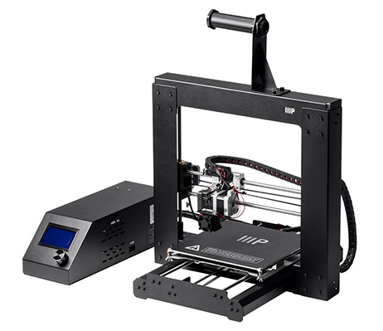1x Mini USB cable

1x 4GB MicroSD™ card with sample 3D model files

1x Scraper

1x PTFE tube

1x Hex key set

6x Hex bolts

2x Cable ties

1x Sample roll of PLA filament (10m/32ft)

2x Print bed mats

1x User's manual

1x Quick install guide

1x Thank you card

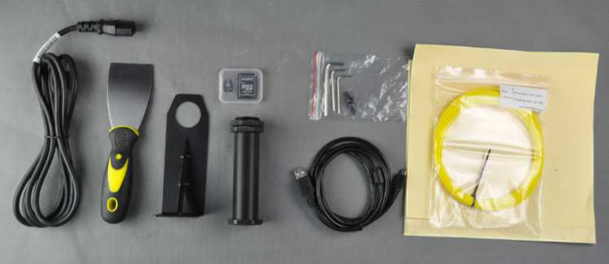

# USING THE MENU SYSTEM

The Power Supply/Control Box features a knob and an LCD display. Throughout this manual you will be asked to navigate the menu system and select specific menu entries. For example, you may be told to select:

**Quick Settings > Home All**

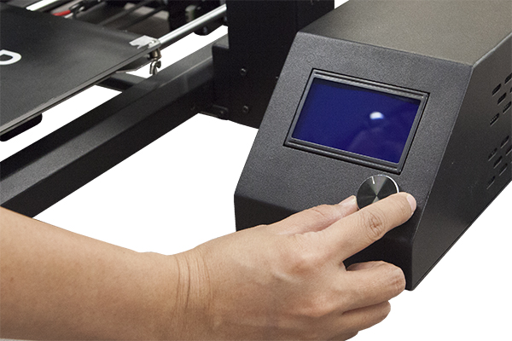To do this, first press the knob to activate the menu system. Rotate the knob until the highlight is on the **Quick Settings** entry, then press the knob to select it. Next, rotate the knob until the **Home All** entry is highlighted, then press the knob to select it.

Most menus have a **Back** option to return to the previous menu. If no option is available, pressing the knob will often return to the previous menu. Additionally, the control box will automatically exit the menus and return to the home screen after about 30 seconds of inactivity. The home screen displays the following information:

 

**Extruder Temperature:** Current °C / Set °C

**Print Bed Temperature:** Current °C / Set °C

**Extruder Coordinates:** X, Y, and Z in millimeters

**Mul:** Displays the current speed multiplier. The default is 100%.

**Buf:** Displays the current number of GCODE steps in the buffer.

**Message Display:**

* **Printer Ready:** The printer is initiated and awaiting input.
* **Idle:** The printer is currently in an idle state.
* **Stepper Disabled:** The stepper motors are disabled and free to be moved by hand.
* **Preheat PLA / Preheat ABS:** Extruder and bed temperatures are set and active.
* **Printing...:** A 3D object is being printed, with the % completed displayed.

**Printing Time:** The total amount of time this printer has spent printing various 3D objects.

**Filament Printed:** The total amount of filament that has been run through the extruder.

# UNPACKING, ASSEMBLY, AND SETUP

1. Open the box, remove the cardboard accessories box, then remove the top layer foam insert.

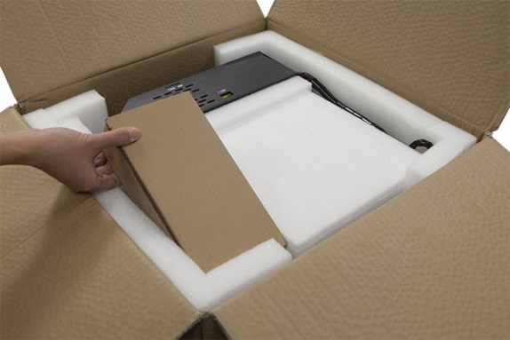 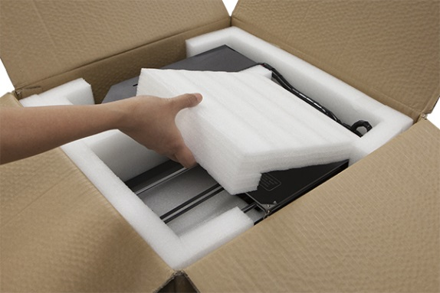

1. Remove the **Printer Base** from the foam packaging and place it onto a flat surface.

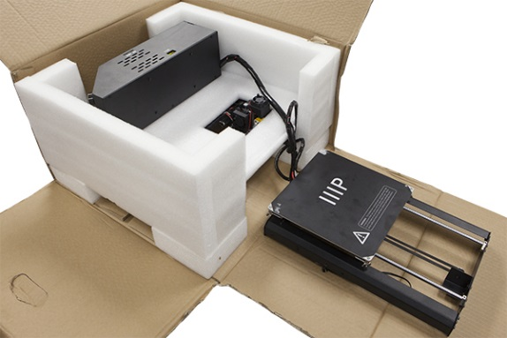

1. Remove the **Power Supply/Control Box**, place it next to the base, then remove the foam insert.

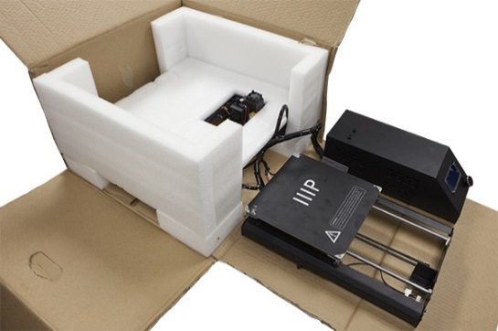 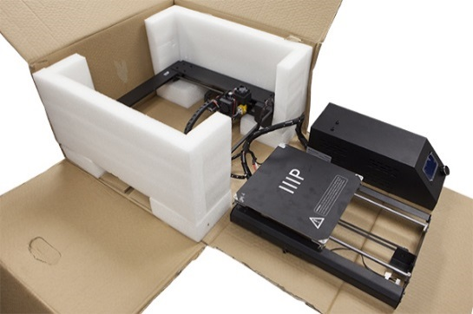

1. Carefully cut the zip tie that secures the **Extruder Assembly** to the **Tower Frame**.



1. Remove the **Tower Frame** and stand it up vertically on the flat surface.

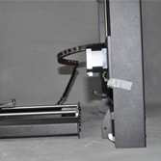

1. Insert the **Printer Base** into the **Tower Frame** and align the screw holes on the frame with those on the base.



1. Open the accessories box and remove four **Hex Screws** and the **Hex Wrench** that fits. Insert a screw into the hole on the frame on the left side and tighten it using the hex wrench. Repeat the process on the right side.

 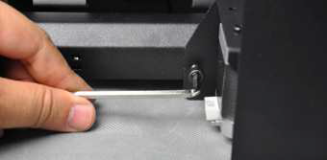

1. Flip the printer onto its left side, then insert a screw from inside the base and secure it to the frame using the hex wrench. Flip the printer onto the other side and repeat the process.

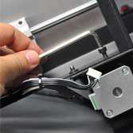 

1. Use a carpenter's level to ensure that your flat surface is level. If it is not level, locate a level surface and place the printer on top of it. Next use the carpenter's level to check that the X-axis guide rods are level. If not, raise or lower either side by manually turning the Z-axis couplers on either side of the frame.

 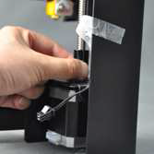 

1. Remove one of the plastic nuts from the threaded end of the **Spool Holder**, but leave the second nut in place. Insert the threaded end of the spool holder through the **Filament Stand**, from the side opposite the base support. Thread the plastic nut onto the spool holder and tighten the plastic nuts on each side of the filament stand.

 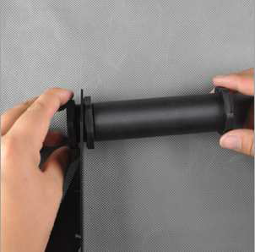

1. You can mount the **Filament Stand** and **Spool Holder** onto either the **Tower Frame** or the **Power Supply/Control Box**. Use two hex screws and the hex wrench to secure it to your desired location. If mounting it to the tower frame, ensure that the spool holder is mounted over the center of the tower frame.

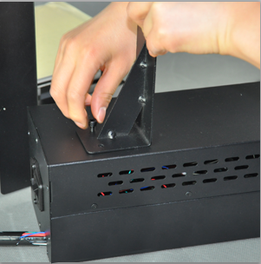 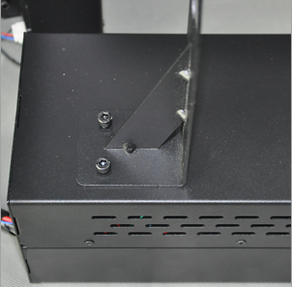 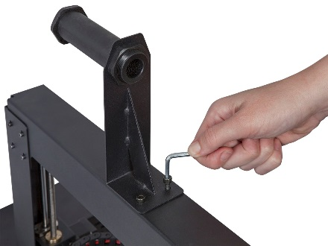

1. The cable assembly on the left side of the base has three cables coiled and secured with a zip tie. Carefully remove the zip tie. On the left side, insert the white connector labeled **A** into the white connector on the bottom of the X-axis stepper motor, also labeled **A**.

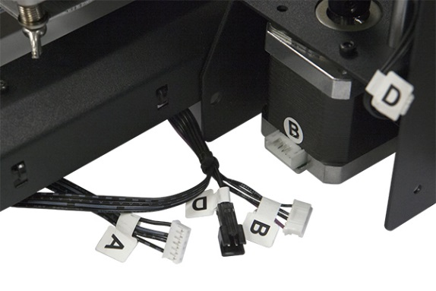 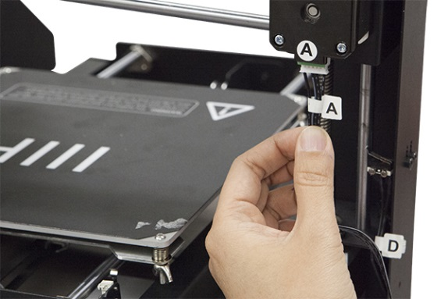

1. On the left side, insert the long cable connector labeled **B** into the motor connector, also labeled **B**.

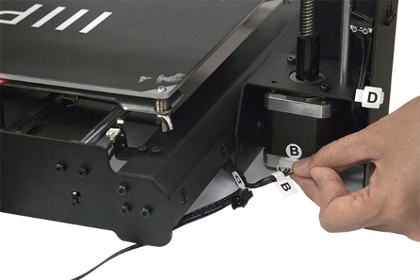

1. On the left side, insert the white connector labeled **C** into the white connector on the stepper motor, also labeled **C**.

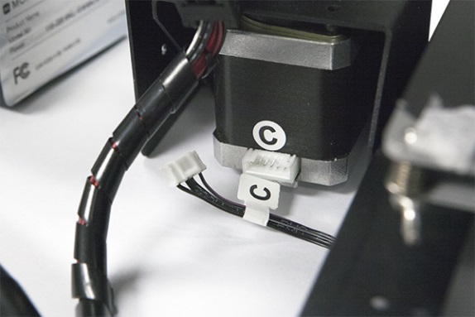

1. Mate the two-pin black cable connector labeled **D** with the corresponding black connector on the cable also labeled **D**, which is attached to the stop switch.

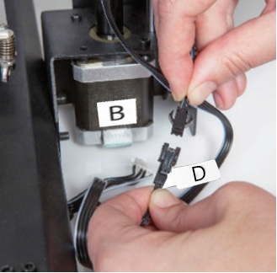

1. Use a lint-free cloth to wipe the top of the aluminum print bed to ensure that no dust or other particles are present. Remove the protective backing from one of the sheets of platform tape and carefully apply it to the platform, ensuring that no bubbles are present. Note that you can also use ordinary masking tape, painter's tape, or Kapton® tape instead of the included platform sheets.

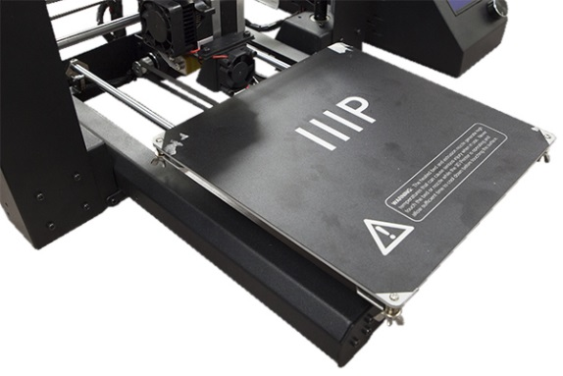

1. One by one, squeeze each corner of the built platform and tighten the knurled nut to compress the spring and reduce the distance between plates to the minimum.

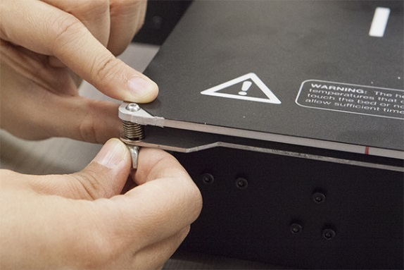

*Note that the above image shows a wingnut. The new printer version uses knurled nuts instead of wingnuts.*

1. Ensure that the power switch is in the OFF position (**O** side depressed). Plug the C13 end of the included **AC Power Cable** into the C14 panel connector on the **Power Supply/Control Box**, then plug the other end into a nearby AC power outlet. Depress the **I** side of the power switch to power the printer ON.

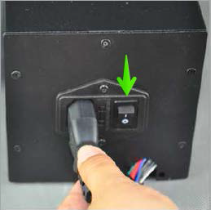

1. Wait for the printer to warm up and initialize. When it is ready, it will display *Printer ready* at the bottom of the LCD display. Select **Quick Settings > Home All**. Wait for the printer to move the build platform and extruder to the home position, then turn the printer off.

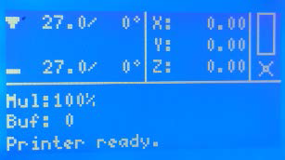

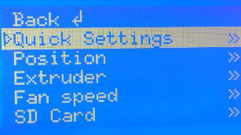 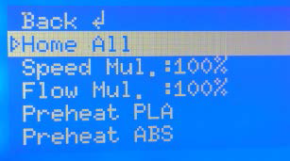

1. Now that the printer is off you can manually move the extruder around the build platform. Because most printing is done near the center of the platform, you should check the nozzle height at points about 2 inches from each corner, as indicated by the blue X marks in the diagram below.

Use a single sheet of ordinary printer paper as a guide. The nozzle is at the correct height when you can just slide a single sheet of paper between the build platform and the nozzle. There should be some resistance to free movement, but moving the extruder should not cause the paper to be dragged with the extruder.

To raise the build platform, loosen the nuts under the build platform. To lower the build platform, tighten the nuts under the build platform. Note that you may need to slightly squeeze the platform to more easily tighten the nuts.

Continue adjusting the platform height until it is at the correct height at all points on the platform.

 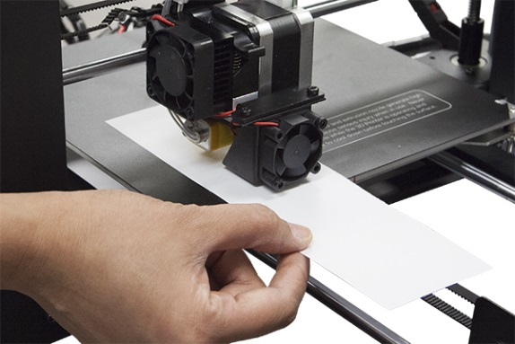

 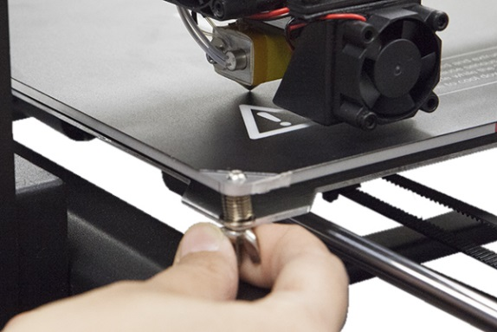

1. Switch the printer on and wait for it to initialize. Select **Position > Z. Pos. Fast**, then turn the knob to raise the extruder so that it is at least an inch above the print bed.

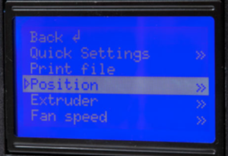 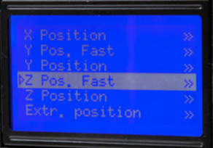

1. Select **Quick Settings > Preheat PLA**. Note that the screen will not change immediately, but will return to the home screen and display *Preheat PLA* at the bottom after about 30 seconds.

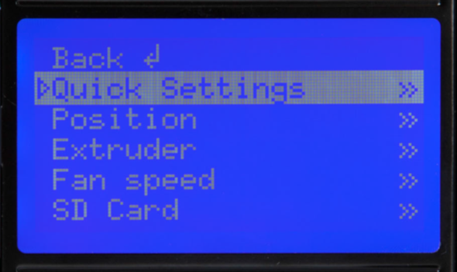 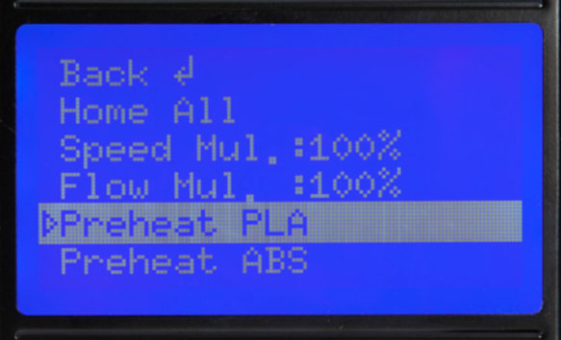

1. Monitor the temperatures of the extruder and plate on the LCD display. When they reach to within a few degrees of the targets, you are ready to insert filament. (Note that the display will still show *Preheat PLA*, even after the temperatures have reached the target values.) Carefully insert the included filament sample into the hole on the extruder, as shown.



1. While holding the filament in place with one hand, select **Extruder > Extr. Position**. Push gently downward on the filament while turning the knob clockwise. You will feel the filament being pulled into the extruder. Continue until a few inches of filament material extrudes out of the nozzle. Carefully clean the extruded filament material off the print bed and nozzle.

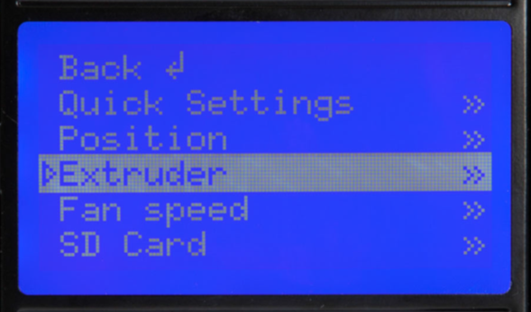 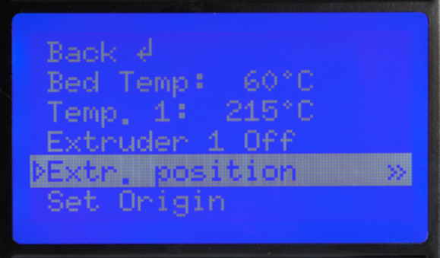

1. Insert the included MicroSD™ card into the slot on the side of the Power Supply, then select **SD Card > Mount Card**. Finally, select **SD Card > Print File**, select one of the sample 3D model files, then press the knob to start printing.

The following table shows the various 3D models found on the included MicroSD card, the size, and the print time required.

|  |  |  |  |  |
| --- | --- | --- | --- | --- |
|  |  |  |  |  |
| **Filename** | Unicorn | M3 Thumbscrew | Vase | WANHAOBot |
| **Size (LxWxH)** | 47 x 19 x 51 mm | 19 x 19 x 4 mm | 50 x 50 x 100 mm | 26 x 34 x 15 mm |
| **Infill %** | 100% | 100% | 0% | 20% |
| **Resolution** | 0.2mm | 0.2mm | 0.2mm | 0.2mm |
| **Print Time** | 50 min. | 6 min. | 1 hr. 43 min. | 36 min. |

*Congratulations, you have successfully setup your new 3D printer and are printing your first model!*

# FINE TUNING PLATFORM HEIGHT

Getting the platform height correct is critical to a successful print. Examine the extruded material and compare it to the following charts to determine if your build platform is a tad too high, a tad too low, or just right. You may need to make several passes at height adjustment before you are ready for a large, complicated print job.

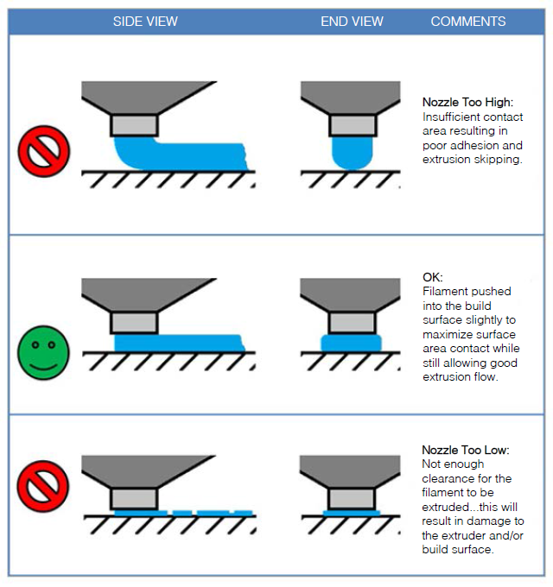

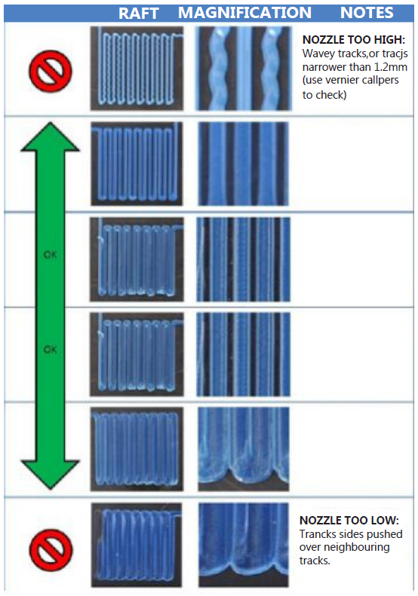

# SOFTWARE

This 3D printer, like most 3D printers, uses freely available 3D printing software. We recommend that you begin your 3D printing experience by using **Cura** to create the Gcode 3D model files. To download the Cura installation program, go to the [www.monoprice.com](http://www.monoprice.com) website, type **13860** into the search bar, then download the client from the product page.

## Installation

Perform the following steps to install the Cura program on your Windows PC:

1. Unzip the installation file, then run the executable. Click the **Next** button to install Cura to the default location. Otherwise, click the **Browse...** button to select a different location.

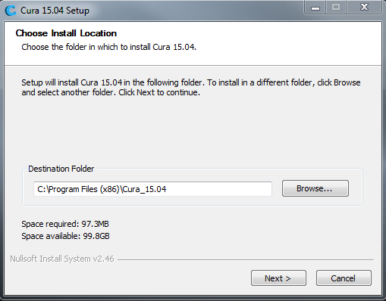

1. Ensure that there is a check mark in all the boxes to install all elements, then click the **Install** button to continue.

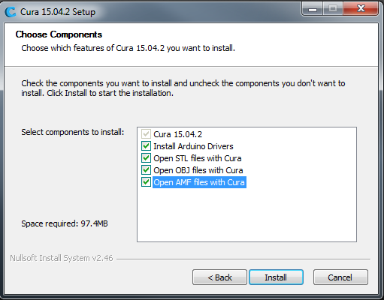

1. The installer will unpack the files to prepare for the installation. When it is done, click the **Next** button to continue.

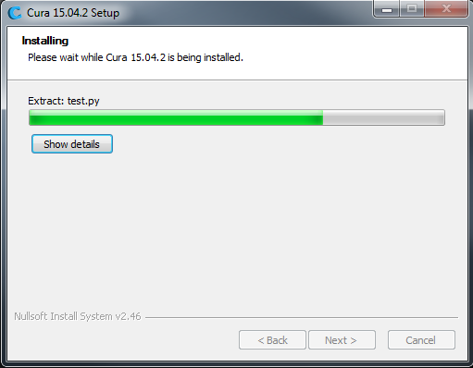 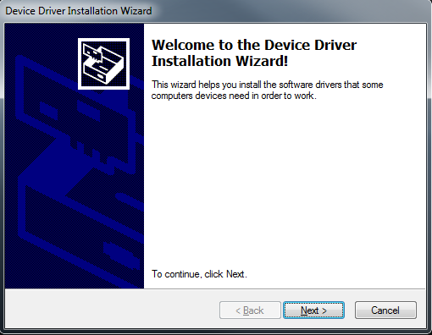

1. Depending on your security settings, the installer will ask you to verify you want to install the unsigned drivers. Click the **Install** button to continue.

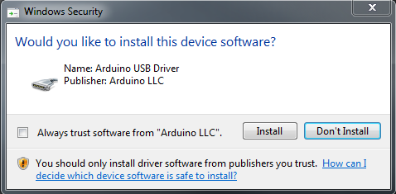 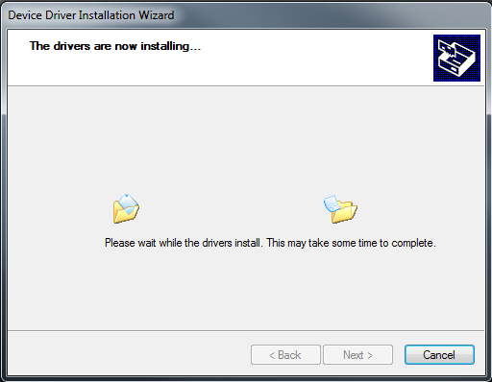

1. Once the drivers are finished installing, click the **Finish** button to continue installing the Cura client.

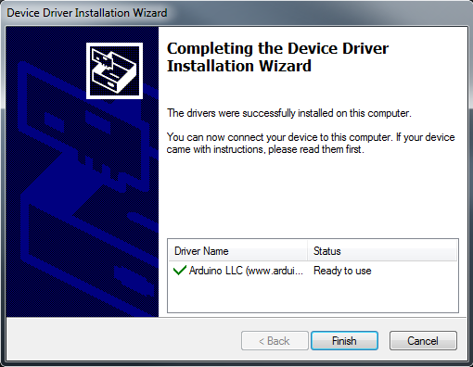

1. Once the software has finished installing, click the **Next** button to continue.

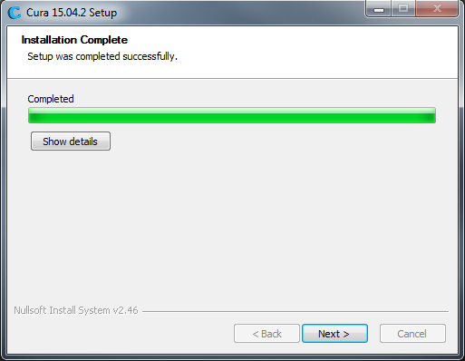

1. Ensure that there is a check mark next to the **Start Cura** entry, then click the **Finish** button to continue.

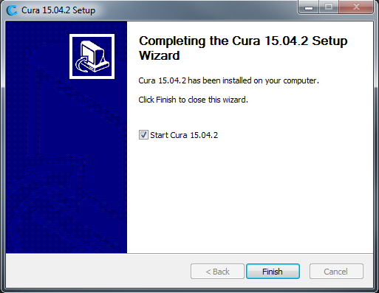

1. Once the client loads, the *First time run wizard* will automatically launch. Click the **Next** button to continue.

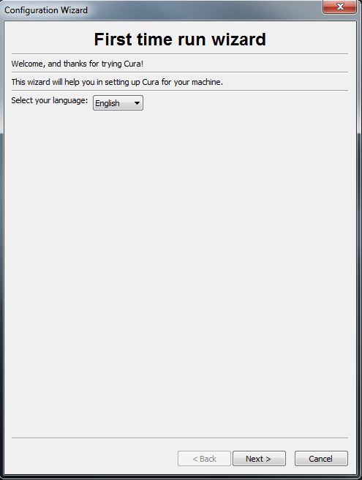

1. Click the radio button to the left of the **Other** (Ex: RepRap, MakerBot, Witbox) entry. By default, the **Submit anonymous usage information** option is enabled. If you do not want to participate, remove the check mark from the box. Click the **Next** button to continue.

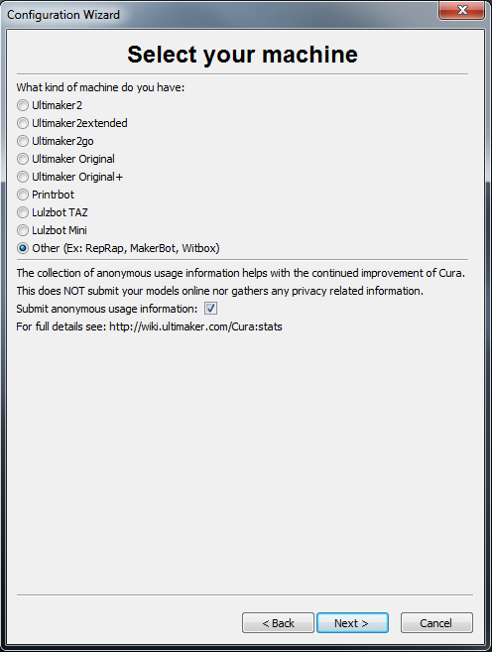

1. Click the radio button to the left of the **Prusa Mendel i3** entry, then click the **Next** button to continue.

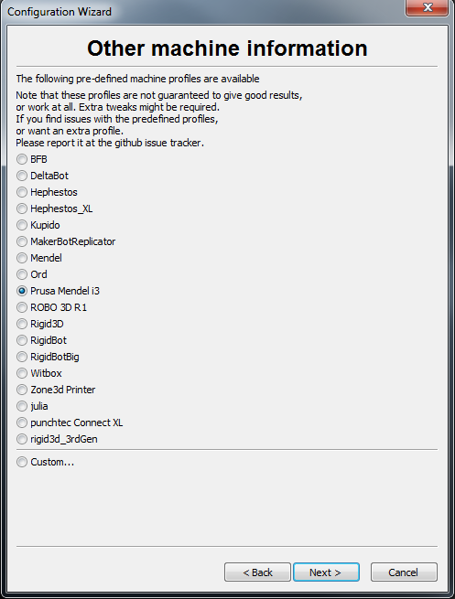

1. The Wizard will now save the machine settings. Click the **Finish** button to complete the process.

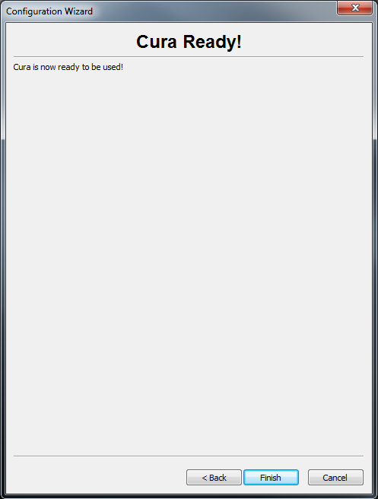

1. A Welcome dialog is now displayed. Click the **OK** button to clear it from the screen.

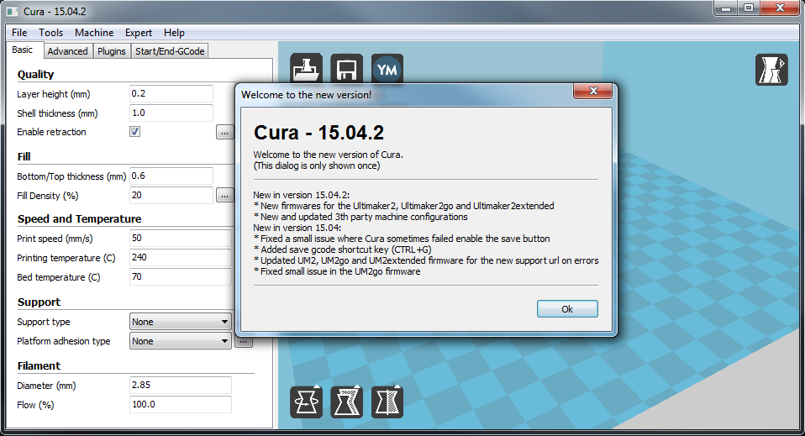

1. Click the **Expert** menu, then click the **Switch to quickprint...** option.

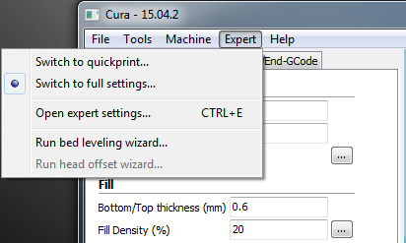

Congratulations, the software and drivers have been installed successfully! We will now take you on a guided tour of the software and explain the various options.

## Quickprint View

**Quickprint Profile -** 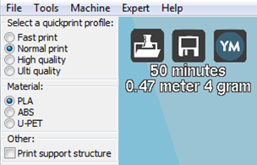Select one of the four options in the *Quickprint profile* section. This entry determines the resolution/quality of the printed object and the amount of time it will take to print. You can select **Fast print** (lowest quality), **Normal print**, **High quality**, and **Ulti quality** (Ultimate). Try clicking the various options and note how the projected print time changes.

**Material -** Select one of three different material options, depending which type of filament you will be using. The printer ships with sample **PLA** filament, but you can also select **ABS** or **U-PET**, which is a newer filament material that combines the benefits of PLA and ABS.

**Print Support Structure -** This printer is capable of printing models with angles and overhangs without support structures, depending on the severity of the angle or overhang. However, it is usually better to use support structures to ensure a successful print. Put a check mark in the box to print with support structures.

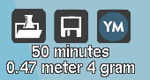**Model Files Buttons -** The three buttons above the time estimate allow you to **Load** model files, **Save** the current model and settings to a model file, or **Share** your model file on the internet.

**Model Manipulation Buttons -** The three buttons at the bottom left of the 3D view allow you **Rotate** the model in three dimensions, **Enlarge or Shrink** the model size, or **Flip** the model in three dimensions. Click one of these buttons to reveal additional options.

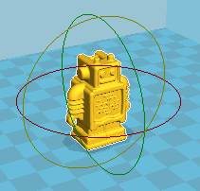**Rotate -** When you click the **Rotate** button, three colored circles are displayed around your model. The Green circle allows rotation in the X axis, the Yellow controls the Y axis, and the Red controls the Z axis. Click one of the circles and drag to rotate within the specified axis. Additionally, it reveals the **Lay Flat** and **Reset** buttons above the Rotate button.

**Lay Flat -** Click the **Lay Flat** icon to ensure that the flat portion of your print is securely attached to the build platform. It is highly recommended to do this after rotating the model in any axis.

**Reset -** Click the **Reset** button to return the model its original orientation.

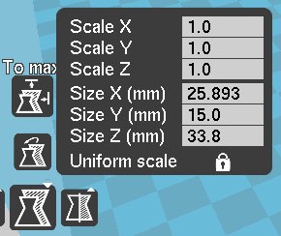**Scale -** When you click the **Scale** button the scale dialog is displayed, along with the **To max** and **Reset** buttons. The dialog allows you to resize the model as a proportion of the original size or using absolute measurements. By default, **Uniform scale** is enabled, which ensures that the amount of scaling in one dimension is mirrored in the other two dimensions, ensuring that the model proportions remain the same. Click the lock in the lower right to disable Uniform scaling if you want to scale the model differently in each dimension.

**To max -** Click the **To max** button to increase the size of the model to the largest possible size.

**Reset -** Click the **Reset** button to restore the model's original dimensions.

**Mirror -** Click the Mirror button to display buttons for flipping the model within the X, Y, and Z axes. Clicking one of the **Reset** buttons will reset any flipping you may have done.

**Rotate View -** Right click within the 3D area and drag to rotate the camera around the model. This allows you to look at the model from any angle.

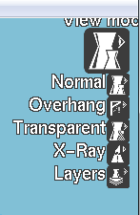**View Modes -** Click the **View mode** button to reveal five view options for looking at your model in different ways.

**Normal -** This is the normal view showing the outer portion of the model.

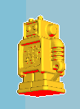**Overhang -** This view highlights in red those areas where your model could benefit from support structures. Use this option to examine your model to make an informed decision about whether to print support structures or not.

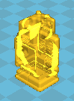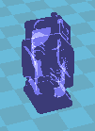**Transparent -** This view removes the skin of the model, allowing you to see any printable elements within.

**X-Ray -** This view is similar to Transparent view in that it allows you to see inside your model.

**Layers -** This view allows you to see the toolpath of the printhead so you can ensure that there are no skipped layers or gaps in the model. Drag the white button on the vertical layer selection bar to move up and down through the toolpath layers.

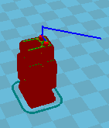  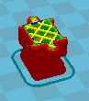 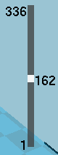

## Full Settings View

Click the **Expert** menu, then click the **Switch to full settings...** option. This allows you to view and adjust all of the possible options to fine-tune your print settings.

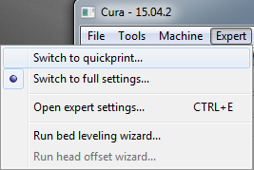

## Basic Tab

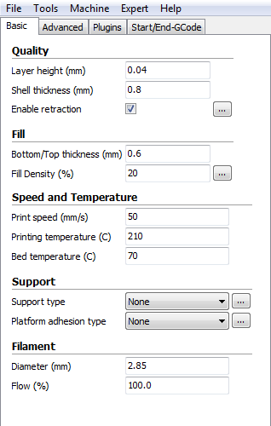Click the **Basic** tab to view the basic build settings.

**Layer Height -** The **Layer Height** determines the thickness of each printed layer. The smaller the layer height, the more layers will be needed and the more time will be required to print, but the printed object will have smoother curves and better detail. Larger layer heights are better for bridging and overhangs.

**Shell Thickness - Shell Thickness** determines the number of vertical walls that comprise the outside of your model. We recommend that you limit this to multiples of your nozzle width, which is 0.4mm on this printer.

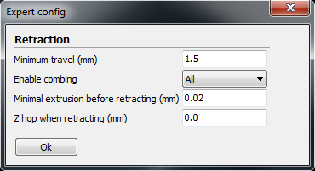**Enable Retraction -** When this option is enabled, the printer will retract filament from the end of the nozzle during non-printing moves/travels. We recommend that you keep this option enabled for all filament types and adjust the retraction length and speed for different filament types. Click the **...** button to the right of the entry to adjust specific values. Refer to the *Expert Settings* section for **Retraction** settings details.

**Bottom/Top Thickness (mm) -** This value determines the thickness of the bottom and top layers of your printed object. Thicker layers can improve strength and print quality, and can help with bridging. We recommend keeping this number to a multiple of your layer height.

**Fill Density (%) -** This value determines the amount of material printed inside the object. A value of 0% will result in a completely hollow model, while a value of 100% results in a completely solid object. We have found that a value of 20% to 40% is good for most prints.

**Print Speed (mm/s) -** This value determines the overall printing speed. If no other speeds are specified in other areas, your printer will default to this speed. The ideal printing speed varies with different filament types.

**Printing Temperature (C) -** This determines the temperature of the print nozzle. Different filament types print at different temperatures. The proper temperatures are specified by the filament manufacturer.

**Bed Temperature (C) -** This determines the temperature of the build platform during printing. Some filament types benefit from using a heated build platform, while other types work well with an unheated build platform covered in masking, painter's, or Kapton® tape.

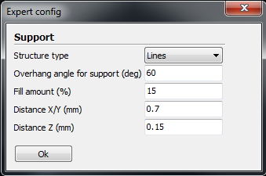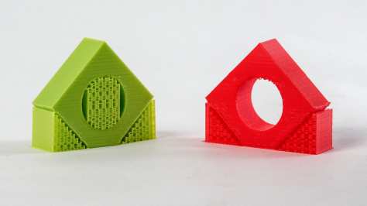**Support Type -** If your print has angles or overhangs, it could benefit from using support material. We recommend orienting your model to minimize or eliminate the need for supports. There are two types of supports possible: **Touching Buildplate** and **Everywhere**. The Touching Buildplate option only creates support for sections of the model that are above the build platform, as shown in the red model, while the Everywhere option provides supports for any overhanging section of the model as shown in the green model. Click the **...** button to adjust specific values controlling the **Support** structures.

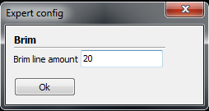**Platform Adhesion Type -** When only a small surface area of your model is designed to touch the build platform, you might experience platform adhesion issues, which could cause your model to come loose during printing. To prevent this, you can use either the **Brim** or **Raft** method to create a larger contact area.

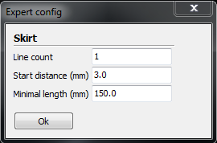The Brim option creates a single layer of filament contacting and surrounding your model, while the Raft option creates a layer of material beneath the model. Click the **...** button to adjust **Skirt** settings (when None is selected), as well as expert settings for the Brim and Raft options. Refer to the *Expert Settings* section for option details.

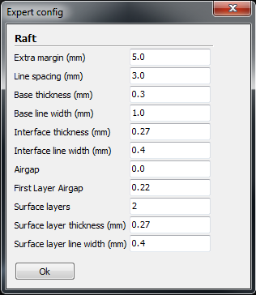

**Diameter (mm) -** This is one of the most important settings to get right. This should be set to the average filament diameter specified by the filament manufacturer.

**Flow (%) -** This determines the amount of filament extruded in relation to the speed. This is used to adjust for filament density variations. We recommend leaving this at 100%, as changing it can lead to surface quality issues.

## Advanced Tab

The options on the **Advanced** tab control machine, quality, and speed issues.

**Nozzle Size (mm) -** This setting tells the software the size of your nozzle, which determines the width of each printed line. This printer has a 0.4mm nozzle size.

**Speed (mm/s) -** This setting determines how quickly the printer will retract filament if you have the filament retraction option enabled on the Basic tab. We recommend keeping this at 25mm/s.

**Distance (mm) -** This setting determines how far the filament is retracted if you have the filament retraction option enabled on the Basic tab. Higher thermal retaining filaments, such as PLA, benefit from longer retraction distances. We have found that a value between 1 - 3 mm is a good starting range.

**Initial Layer Thickness (mm) -** This value determines the thickness of the initial layer printed on the print bed. A thicker initial layer can help prevent adhesion issues. However, adjusting this value can cause problems with the printer's leveling system, so we recommend leaving this at the default values. Adjust at your own risk.

**Initial Layer Width (mm) -** This value determines the width of your first printed layer. A wider layer can help prevent adhesion issues. We suggest 125% as a good starting value.

**Dual Extrusion Overlap (mm) -** This value determines how much overlap there is between filament when using a dual extrusion head and printing two colors. This helps the two different colors adhere to each other. This printer uses a single extrusion head.

**Travel Speed (mm/s) -** This value determines how quickly the printer moves the print head when not extruding filament. We recommend a travel speed between 125 - 150 mm/s.

**Bottom Layer Speed (mm/s) -** This value determines the printing speed for the initial layer. A slower speed for the initial layer can help improve first layer adhesion.

**Infill Speed (mm/s) -** This value determines the print speed when printing areas inside the model. Usually this can be faster than normal printing, but if set too fast can cause adhesion issues or globs of material to be extruded.

**Top/Bottom Speed (mm/s) -** This value determine the print speed when printing the initial and the final layers of the model.

**Outer Shell Speed (mm/s) -** This value determines the print speed when printing the outer shell. This is important because it affects the visible portion of your model. Slower printing speeds are recommended for better looking prints.

**Inner Shell Speed (mm/s) -** This value determines the print speed when printing vertical walls between the outer shell and the infill. We recommend keeping this setting between the values set for the Infill and Outer Shell speeds.

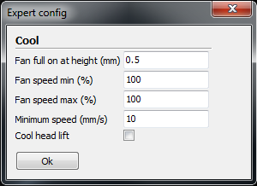**Minimal Layer Time (sec) -** This value determines the minimum amount of time to spend printing each layer. If the amount of time falls below this value the printer will slow printing to bring the time to this value. Tweaking this value can result in cleaner, crisper prints.

**Enable Cooling Fan -** This allows you to enable or disable the use of the cooling fan. Click the **...** button to view and adjust specific values. Refer to the *Expert Settings* section for details.

## Plugins Tab

Plugins are custom functions that can alter your print at specific points. Cura is prepackaged with the **Tweak at Z** and **Pause at Height** plugins. You can find more plugins at:

<http://wiki.ultimaker.com/Category:CuraPlugin>

To activate a plugin, highlight it and click the down arrow button to move it to the Enabled Plugins box.

**Tweak at Z -** This plugin allows you to specify different settings for specific heights or layer counts.

**Pause at Z Height -** This plugin allows you to tell the printer to pause printing when the model reaches a specific height or layer count. This is most commonly used when changing filament color in the middle of a print.

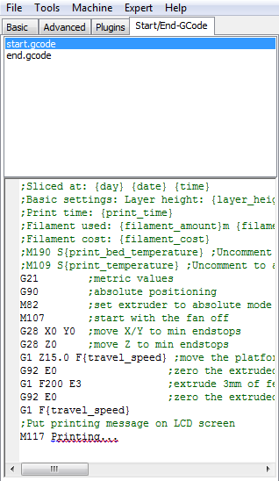**Start/End-Gcode Tab**

Custom Gcode allows for complex automatic printer movements and operations. By adding custom Gcode into the start or end of your file, you can alter how it prints. A comprehensive list of Gcode commands can at:

<http://reprap.org/wiki/G-code>

We recommend that you leave this as provided by the printer profiles until you have gained more experience with Gcode.

## Expert Settings

Press **CTRL+E** or select **Expert > Open expert settings...** menu entry to display the Expert Settings dialog. This will give you more specific control over various functions and consolidates onto one dialog the various expert settings dialogs mentioned above.

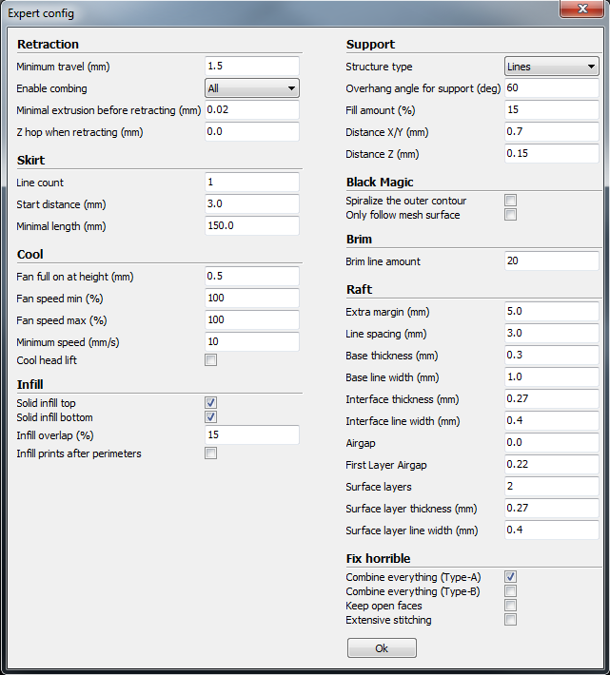

**Retraction**

The Retraction option allows the printer to retract filament from the end of the nozzle during non-printing moves/travels.

**Minimum Travel (mm) -** The value specifies the minimum distance the printhead can move before filament retraction is performed.

**Enable Combing -** This option prevents the printhead from traveling over holes in the layer. This slightly increases print time, but prevents filament strings from extruding into the holes. We recommend leaving this on for all prints.

**Minimal Extrusion Before Retracting (mm) -** This determines the minimum amount of filament that must be extruded between travels before retraction will occur.

**Z Hop When Retracting (mm) -** This will raise your printhead the specified distance when performing a travel. It helps prevent ooze or strings from being deposited on your print.

**Skirt**

The Skirt option prints one or more lines around the outside of your object. This is primarily used to prime the extruder to prevent missed filament at the beginning of a print. You should leave this on.

**Line Count -** This value determines the number of loops that will printed around your object. Smaller models should use a higher value to give the printer sufficient time to prime the extruder.

**Start Distance (mm) -** This value determines the distance away from your model that the skirt will be created. If using the skirt to prevent drafts, the skirt should be closer to the object.

**Minimal Length (mm) -** This value determines the minimum line length for the skirt. This will override your line count as required to extrude the specified amount of filament.

**Cool**

The Cool section controls the operation of the cooling fan while printing.

**Fan Full On At Height (mm) -** This determines the vertical height at which the fan will run at its maximum speed. This is especially useful for high thermal retaining filaments, such as PLA.

**Fan Speed Min (%) -** This value sets the minimum fan speed to be used when the fan is turned on. This is set as a percentage of the maximum speed.

**Fan Speed Max (%) -** This value sets the maximum fan speed to be used when the fan is turned on. This is set as a percentage of the maximum speed.

**Minimum Speed (mm/s) -** The *Minimal Layer Time* can cause the print to slow down so much it oozes. This setting protects against this by ensuring that the print never slows below this value.

**Cool Head Lift -** When enabled, this option lifts the printhead if the minimum speed is activated because of a cooling slowdown.

**Infill**

The Infill section sets fine details controlling infill printing.

**Solid Infill Top -** When enabled, you will have a solid top layer. When disabled, the top layer will be filled at the *Fill Percentage* rate. Disabling this option is useful when printing cups and vases.

**Solid Infill Bottom -** When enabled, you will have a solid bottom layer. When disabled, the bottom layer will be filled at the *Fill Percentage* rate. Disabling this option is useful when printing buildings or caps.

**Infill Overlap (%) -** This value specifies the amount of overlap between the infill and the walls. Some amount of overlap is necessary to ensure a firm connection between the infill and walls.

**Infill Prints After Perimeters -** When enabled, the printer will print the infill after it prints the perimeter, which can reduce the amount of infill that shows through the surface. When disabled, the infill is printed before the perimeter lines.

**Support**

If your print has angles or overhangs, it could benefit from using support material. This section controls support structure details.

**Structure Type -** This determines the type of support structure used in the print. You can choose **Lines** or **Grid**. With Grid you get a checkerboard grid on the X and Y axes, while the Lines option provides lines in the Y axis only. The grid produces stronger supports, but are more difficult to remove.

**Overhang Angle for Support (deg) -** This determines where support material is generated. In general, you should be able to print overhangs greater than 45 degrees without support. We recommend setting this to 45 degrees.

**Fill Amount (%) -** Similar to the Infill setting, this determines the density of the support material. Higher values will provide better support, but will be more difficult to remove.

**Distance X/Y (mm) -** This value determines the distance from your object in the X and Y axes to print support material.

**Distance Z (mm) -** This value determines the minimum vertical distance at which support material is printed. A smaller value will provide better support, but will be more difficult to remove.

**Black Magic**

The Black Magic section allows you to modify your model to produce either a solid model or a hollow shell a single layer thick.

**Spiralizing The Outer Contour -** When enabled, this option causes your Z axis to be constantly moving upward as you print the outer shell. The results are no layer change lines, resulting in much smoother surface. This is typically only used for artistic objects, as they tend be very fragile.

**Only Follow Mesh Surface -** When enabled, this option causes your Z axis to be constantly moving upward as you print the outer shell. Unlike the Spiralizing option, this moves the Z axis normally.

**Brim**

The Brim is a single layer around the base of your print to improve adhesion to the build platform.

**Brim Line Amount -** This value specifies the number of lines to print around the outside of your object. The more lines used, the better the object will adhere to the build platform.

**Raft**

The Raft is a platform built underneath your object to help adhesion and to prevent warping. This will print a support structure followed by a platform upon which your model will be printed. The bottom surface of your object will not be as clean or even when using this option. Raft is typically not recommended.

**Extra Margin (mm) -** This value determines the distance around your object to build the raft.

**Line Spacing (mm) -** This value determines the spacing between the support lines when creating the raft. A small value will improve strength, but will use more material.

**Base Thickness (mm) -** This value determines the thickness of the raft.

**Base Line Width (mm) -** This determines the width of the support lines used when creating the raft and determines how well the surface layers of the raft print.

**Interface Thickness (mm) -** This value determines the thickness of the surface layers that are built on the supports.

**Interface Line Width (mm) -** This determines the width of the surface layers on the raft. In general, you can set this to your nozzle size as print quality on the raft is not important.

**Airgap -** This value determines the distance between the raft and your print. A larger distance will make it easier to remove the raft, but will reduce the quality of the bottom of your print.

**First Layer Airgap -** This value determines the gap between the raft and the first layer.

**Surface Layers -** This value determines the number of layers used to print the raft's surface.

**Surface Layer Thickness (mm) -** This value determines the thickness of the surface layers.

**Surface Layer Line Width (mm) -** This value determines the width of the surface layer lines. In general you can set this to your nozzle size as print quality is not important for the raft.

**Fix Horrible**

These advanced options are designed to repair models with errors to make them suitable for 3D printing. They do not always work and can have unexpected results. Be cautious in using these options.

**Combine Everything (Type A) -** This attempts to fix all external mesh errors, while keeping internal holes intact. This can inadvertently fill intentional internal holes.

**Combine Everything (Type B) -** This option attempts to fix all external mesh errors, while ignoring all internal holes. This option is useful for times when only the external shell of the print is important.

**Keep Open Faces -** This option ignores all manifold errors in the object. It can create issues when generating Gcode as Cura does not know how to interpret the open holes. This option should only be used when you are sure that holes in the mesh are intentional. In general, avoid using this option.

**Extensive Stitching -** This option causes Cura to automatically add triangle meshes in an attempt to fix manifold errors. This algorithm will greatly increase Gcode generation time and may end up adding unintended meshes. It is recommended that you repair your model using Meshlab or your CAD program before attempting this option.

# TECHNICAL SUPPORT

Monoprice is pleased to provide free, live, online technical support to assist you with any questions you may have about installation, setup, troubleshooting, or product recommendations. If you ever need assistance with your new product, please come online to talk to one of our friendly and knowledgeable Tech Support Associates. Technical support is available through the online chat button on our website **www.monoprice.com** during regular business hours, 7 days a week. You can also get assistance through email by sending a message to **tech@monoprice.com**

# TROUBLESHOOTING

Q1: There is a clicking sound from one of the stepper motors.

A1: One of the stepper motors may not be connected properly. Check each connection and then inspect the cable routing for any faults.

Q2: The GCODE file on the MicroSD™ card is not printing.

A2: Remove the MicroSD card and insert it into your computer. Open the GCODE file using a text editor (e.g., Notepad), and check whether the GCODE is readable or not. If the file consists of multiple ÿÿÿÿ symbols (for example), the file has been corrupted. Try reformatting your MicroSD™ card and reloading the GCODE file. Note that this will delete all files on the MicroSD card.

Q3: Filament is not extruding from the nozzle when a print is started.

A3: Ensure that the nozzle temperature is set to the correct value for the type of material being printed.

Q4: The 3D object is not sticking to the heated print bed.

A4: Check the following issues:

* Ensure that the print bed is clean and free from dust.
* Check that the bed is level and is the proper distance from the extruder nozzle, which is the thickness of a sheet of printer paper.
* Check to see if there are defects or scratches in the printing mat and change it as necessary. You can use one of the included printing mats, ordinary masking tape, painter's tape, or Kapton® tape.
* Add a brim or raft to the model.
* Check that the temperature of the heated print bed is correct for the type of material being printed.

Q5: The printed model is warping or curling.

A5: Check the following issues:

* Check that the temperature of the heated print bed is correct for the type of material being printed.
* Check the infill % of your GCODE. The higher the infill, the more likely it is for the model to warp.
* Add a brim or raft to your file.

Q6: The model appears very 'stringy'.

A6: Check the following issues:

* Ensure that the filament diameter is set to match your filament spool (1.75mm), then try creating a new GCODE file before printing again.
* Ensure that the nozzle temperature is set to the correct value for the type of material being printed.

Q7: The print stopped during the print process.

A7: Check the following issues:

* Check that the GCODE file is complete and not corrupted.
* Check the original model file.

Q8: The motor does not stop at the end of the axis.

A8: Check that the stop micro switches are aligned with the motor mount and are being activated.

Q9: The print head or bed does not move.

A9: Check the following issues:

* Turn the printer off or disable the stepper motors and verify that the parts can be moved by hand. Clear anything that is blocking the movement path.
* Use the options in the positioning menu to verify that the motor is turning. If the motor turns, but the belt does not move, you need to tighten the gear motor gear nut.

Q10: The printer is not powering on.

A10: Verify that the power cord is properly plugged into the control box, is plugged into a power outlet, and that the power outlet is live.

Q11: The MicroSD™ card cannot be read.

A11: Navigate the menu system to the SD Card menu, select **Unmount SD Card**, then select **Mount SD Card**.

# SPECIFICATIONS

|  |  |
| --- | --- |
| Print Technology | Fused Filament Fabrication (FFF) |
| Build Area | 7.9" x 7.9" x 7.1" (200 x 200 x 180mm) |
| Layer Resolution | 0.1 – 0.4mm |
| Positioning Accuracy | X 0.012mm |
| Y 0.012mm |
| Z 0.004mm |
| Extruder Quantity | Single Extruder |
| Nozzle Diameter | 0.4mm |
| Print Speed | 10 - 70 mm/sec |
| Travel Speed | 10 - 70 mm/sec |
| Supported Print Materials | PLA, ABS, PVA, HIPS, Wood, Flex, Conductive |
| Ambient Operating Temperature | +59 - +86°F (+15 – +30°C) |
| Operational Extruder Temperature | +338 - +464°F (+170 - +240°C) |
| Operational Print Bed Temperature | +86 - +158°F (+30 - +70°C) |
| Slicer Software | Cura Wanhao Edition 15.04 |
| Cura Input Formats | .STL, .OBJ, .DAE, .AMF |
| Cura Output Format | .GCODE |
| Connectivity | MicroSD™ card, Mini USB port |
| Input Rating | 100-120 VAC, 60Hz, 3.5A |
| Printer Frame Dimensions | 15.7" x 16.1" x 15.7" (400 x 410 x 400mm) |
| Weight | 22 lbs. (10kg) |

# APPENDIX A: CONTROL BOX MENU REFERENCE

## Main Menu

**Quick Settings >>** Opens the quick settings menu.

**Print file** Allows printing of 3D model files on the inserted MicroSD™ card.

**Position >>** Opens the position menu, which allows you to automatically or manually position the extruder and built platform.

**Extruder >>** Opens the extruder menu.

**Fan speed >>** Opens the fan speed menu.

**SD Card >>** Opens the SD™ card menu.

**Debugging >>** Opens the debugging menu.

**Configuration >>** Opens the configuration submenu.

## Quick Settings Menu

**Back** Returns to the Main Menu.

**Home All** Moves the extruder and build platform to their home locations.

**Speed Mul. 100%** Scales the printing speed.

**Flow Mul. 100%** Scales the speed of filament flow.

**Preheat PLA** Select this entry to preheat the printer for use with PLA filament. This sets the Extruder temperature to 215°C and the Heated Print Bed to 60°C.

**Preheat ABS** Select this entry to preheat the printer for use with ABS filament. This sets the Extruder temperature to 245°C and the Heated Print Bed to 90°C.

**Cooldown** Select this entry to turn off the heaters to allow the extruder and build platform to cool down.

**Disable/Enable stepper** Allows you to enable or disable the stepper motors. When disabled, you can physically move the extruder in the X, Y, and Z axes.

## Position Menu

**Back** Returns to the Main Menu.

**Home All** Moves the extruder and build platform to the home position for the X, Y, and Z axes.

**Home X** Moves the extruder to the home position for the X axis only.

**Home Y** Moves the build platform to the home position for the Y axis only.

**Home Z** Moves the extruder to the home position for the Z axis only.

**X Pos. Fast >>** Allows you to quickly move the extruder on the X axis.

**X Position >>** Allows you to slowly move the extruder on the X axis.

**Y Pos. Fast >>** Allows you to quickly move the build platform on the Y axis.

**Y Position >>** Allows you to slowly move the build platform on the Y axis.

**Z Pos. Fast >>** Allows you to quickly move the extruder on the Z axis.

**Z Position >>** Allows you to slowly move the extruder on the Z axis.

**Extr. position >>** Allows you to manually extrude filament material.

## Extruder

**Back** Returns to the Main Menu.

**Bed Temp 0°C** Allows you to set the target bed temperature. This can be set to 0 and 30-100 in increments of 1.

**Temp 1 0°C** Allows you to set the target nozzle temperature for the first extruder. If a dual extrusion head is installed, a Temp 2 option will also be displayed. This can be set to 0 and 170 - 260 in increments of 1.

**Extruder 1 Off** Disables the first extruder in a dual extruder system.

**Extr. position >>** Allows you to manually extrude filament material.

**Set Origin** Resets the extruder position to the factory settings when a dual extruder head is installed.

## Fan Speed

**Back** Returns to the Main Menu.

**Fan Speed 0%** Sets the fan speed to 0% of maximum.

**Set Fan Off** Turns the fan off.

**Set Fan 25%** Sets the fan speed to 25% of maximum.

**Set Fan 50%** Sets the fan speed to 50% of maximum.

**Set Fan 75%** Sets the fan speed to 75% of maximum.

**Set Fan Full** Sets the fan to 100% of maximum.

## SD Card

**Back** Returns to the Main Menu.

**Print file** Allows you to select and print a file from the MicroSD™ card.

**Mount/Unmount Card** Allows you to mount or unmount the MicroSD card so you can safely remove it.

**Delete file** Allows you to select and delete a file from the MicroSD card.

## Debugging

This menu allows you to enable or disable various debugging options for use when executing Gcode.

**Back** Returns to the Main Menu.

**Echo on/off** When enabled, an alarm is sounded when a syntax error is encountered.

**Info on/off** When enabled, the error details are displayed when a syntax error is encountered.

**Errors on/off** When enabled, the system will display the line number when a syntax error is encountered.

**Dry run on/off** When enabled, Gcode execution will continue after a syntax error is encountered.

## Configuration

**Back** Returns to the Main Menu.

**General >>** Opens the general configuration options menu.

**Acceleration >>** Opens the acceleration configuration options menu.

**Feedrate >>** Opens the feedrate configuration options menu.

**Extruder >>** Opens the extruder configuration options menu.

**Store to EEPROM** Saves the current settings to the built-in EEPROM memory.

**Load f. EEPROM** Allows you to load settings from those previously saved to the built-in EEPROM memory.

## Configuration >> General

**Back** Returns to the Configuration Menu.

**Baudrate** Allows you to set the serial communications speed. This can be set to 9600, 14400, 19200, 28800, 38400, 56000, 57600, 76800, 111112, 115200, 128000, 230400, 250000, 256000, 460800, 500000, 921600, 1000000, or 1500000.

**Stepper Inactive >> Dis. After XXX [s]** Disables the stepper motors after the specified inactive time. The possible values are 0 - 10080 in 60 sec increments.

**Max. Inactive >> Dis. After XXX [s]** Disables the extruder after the specified inactive time. The possible values are 0 - 10080 in 60 sec increments.

## Configuration >> Acceleration

**Back** Returns to the Configuration Menu.

**Print X** The possible values are 0-10000 in increments of 100.

**Print Y** The possible values are 0-10000 in increments of 1.

**Print Z** The possible values are 0 - 10000 in increments of 100.

**Move X** The possible values are 0 - 10000 in increments of 100.

**Move Y** The possible values are 0 - 10000 in increments of 100.

**Move Z** The possible values are 0 - 10000 in increments of 1.

**Jerk** The possible values are 1.0 - 99.9 in increments of 0.1.

**Z-Jerk** The possible values are 0.1 - 99.9 in increments of 0.1.

## Configuration >> Feedrate

**Back** Returns to the Configuration Menu.

**Max X** The possible values are 1 - 1000 in increments of 1.

**Max Y** The possible values are 1 - 1000 in increments of 1.

**Max Z** The possible values are 1 - 1000 in increments of 1.

**Home X** The possible values are 5 - 1000 in increments of 1.

**Home Y** The possible values are 5 - 1000 in increments of 1.

**Home Z** The possible values are 1 - 1000 in increments of 1.

## Configuration >> Extruder

**Back** Returns to the Configuration Menu.

**Steps/MM** The possible values are 1.0 - 9999.0 in increments of 1.0.

**Start FR** The possible values are 1 - 999 in increments of 1.

**Max FR** The possible values are 1 - 999 in increments of 1.

**Accel** The possible values are 10 - 99999 in increments of 10.

**Stab.Time** The possible values are 0 - 999 in increments of 1.

**Wait Units (mm)** The possible values are 0 - 99 in increments of 1.

**Wait Time (°C)** The possible values are 100 - 260 in increments of 1.

**Control Dead Time** The possible options are BangBang, PID, SlowBang, and Dead Time.

**DT/PID P** The possible values are 0.0 - 200.0 in increments of 0.1.

**PID I** The possible values are 0.00 - 100.00 in increments of 0.01.

**PID D** The possible values are 0.00 - 200.00 in increments of 0.1.

**Drive Min** The possible values are 1 - 255 in increments of 1.

**Drive Max** The possible values are 1 - 255 in increments of 1.

**PID Max** The possible values are 1 - 255 in increments of 1.

# APPENDIX B: DEFAULT VALUES

The following table lists all of the default values for this printer.

|  |  |  |  |
| --- | --- | --- | --- |
| **General** | | **Extruder** | |
| Baudrate | 115200 | Steps/mm | 96.0 |
| Stepper Inactive Time | 360 seconds | Start FR | 20 |
| Max Inactive Time | 0 seconds | Max FR | 50 |
|  | | Accel | 5000 |
| **Acceleration** | | Stab. Time | 1 |
| Print X | 1000 | Wait Units | 0mm |
| Print Y | 1000 | Wait Temp. | 150C |
| Print Z | 100 | Control | Dead Time |
| Move | X | DT/PID P | 7.00 |
| Move | Y | PID I | 2.00 |
| Move | Z | PID D | 40.00 |
| Jerk | 20.0 | Drive Min. | 40 |
| Z-Jerk | 0.3 | Drive Max. | 230 |
|  | | PID Max. | 255 |
| **Feedrate** | |  | |
| Max X | 200 |
| Max Y | 200 |
| Max Z | 2 |
| Home X | 40 |
| Home Y | 40 |
| Home Z | 2 |

# REGULATORY COMPLIANCE

## Notice for FCC



This device complies with Part 15 of the FCC rules. Operation is subject to the following two conditions: (1) this device may not cause harmful interference, and (2) this device must accept any interference received, including interference that may cause undesired operation.

Modifying the equipment without Monoprice's authorization may result in the equipment no longer complying with FCC requirements for Class B digital devices. In that event, your right to use the equipment may be limited by FCC regulations, and you may be required to correct any interference to radio or television communications at your own expense.

This equipment has been tested and found to comply with the limits for a Class B digital device, pursuant to Part 15 of the FCC Rules. These limits are designed to provide reasonable protection against harmful interference in a residential installation. This equipment generates, uses and can radiate radio frequency energy and, if not installed and used in accordance with the instructions, may cause harmful interference to radio communications. However, there is no guarantee that interference will not occur in a particular installation. If this equipment does cause harmful interference to radio or television reception, which can be determined by turning the equipment off and on, the user is encouraged to try to correct the interference by one or more of the following measures:

* Reorient or relocate the receiving antenna.
* Increase the separation between the equipment and receiver.
* Connect the equipment into an outlet on a circuit different from that to which the receiver is connected.
* Consult the dealer or an experienced radio/TV technician for help.

## Notice for Industry Canada



This Class B digital apparatus complies with Canadian ICES-003.

Cet appareil numérique de la classe B est conforme à la norme NMB-003 du Canada.

*SD, SDHC, SDXC, microSD, microSDHC, and microSDXC are all trademarks or registered trademarks of SD-3C, LLC in the United States, other countries, or both.*

*Microsoft and Windows are registered trademarks of Microsoft Corporation in the United States and/or other countries.*

*Apple, Mac, and OS X are trademarks of Apple Inc., registered in the U.S. and other countries.*

*DuPont and Kapton are trademarks or registered trademarks of E.I. du Pont de Nemours and Company.*